
Cagayan De Oro College-PHINMA Education Network

Appointment Scheduler: A Console-Based School Uniform Appointment System.
------------------------------------------------------------------------------------------------------

Introduction To Computing Project
Presented to the
Faculty of the College of Information Technology
Cagayan de Oro College
Cagayan de Oro City

-----------------------------------------------------------------------------------------------------

In Partial Fulfillment
of the Requirements for the
Degree Bachelor of Science in Information Technology

-----------------------------------------------------------------------------------------------------

NAME OF RESEARCHER

HERADURA, RENZ L.
RANIDO, PRECIOUS JOURIE J
LLAGAS, KEN C.
DIRECTO, JAMES BRIAN N.
MONTEZA, GEAN KARL A.
AUSTRIA, ETHAN SETH J.
CONTRATISTA, R-JAY B.

OCTOBER, 2026

Cagayan De Oro College-PHINMA Education Network

1.1 Introduction
In a school environment, getting a uniform should be a simple process, but it can become stressful to the staff/authorized personnel when many students need the same service at the same time. A manual and walk-in processes can result in long waiting times, overcrowding, and difficulty managing the number of students being served. Students and school personnel can use digital systems to manage services more efficiently. According to the study by Wiratama et al. (2023) examined the development of a web-based school uniform application and found that conventional methods of handling uniform-related information, including manual recording and measurement, were time-consuming and difficult to manage when dealing with a large volume of data, these usual uniform-related transactions can become slow and hard to manage. Students at PHINMA–Cagayan de Oro College may have to wait in long hours when appointing their school uniforms or dealing with other uniform-related services and they are unsure whether they will be able to complete their appointment on that exact date/time. This circumstances influence student expectation and efforts. Additionally, a school when under constructed or building under construction is one factor that students feel anxious or uncomfortable when they wait for uniform services. Therefore, a console-based system is presented for students and staff to manage school uniform appointment, they just simply provide important information to verify the staff and organize the transactions such as, uniform fitting, claiming, and concerns without hustling themselves. While manual appointment processes can be difficult to manage when many students require the same service, an organized scheduling system can minimize scheduling conflicts and reduce unnecessary waiting time (Ampuan & Delena, 2022).

Cagayan De Oro College-PHINMA Education Network

In line with the context and observations with the school uniform appointment staff and students, we pinpointed the proposed Appointment Scheduler: A Console-Based School Uniform Appointment System that designed to provide a more organized process for managing school uniform-related appointments at PHINMA–Cagayan de Oro College Puerto Campus for students and staff. Instead of relying mainly on walk-in transactions, students can provide their identification number, name, gender, phone number, course, year level, uniform type, uniform size, and selected service, such as uniform fitting, uniform claiming, and uniform concern. They can also select an available appointment date and time. The system records these details and generates an appointment code and queue number for monitoring. To ensure that they are the students in PHINMA–Cagayan de Oro College Puerto Campus only, before proceeding to the office, they must bring their generated code and together with their Official Registration Form (ORF) for their identification. For authorized personnel, the proposed system provides functions to view active appointments, verify appointment details, monitor the queue, and mark completed transactions as done. Students can also check, update, or cancel their active appointments when necessary. These functions are intended to help staff maintain an organized record of students and manage the number of students scheduled for each date.

This approach is supported by Maala, Sebua, and Evangelista (2023) emphasized that a well-organized queuing system in educational institutions can help shorten waiting times, improve workflow, and support better service management. Similarly, Ampuan and Delena (2022), address that inefficient appointment handling can cause person waiting over time, through digital appointment systems, it can help users/students schedule their appointments more conveniently and improve the management flow.
Cagayan De Oro College-PHINMA Education Network

1.2 Statement of the Problem
General Problem
The lack of a structured appointment scheduling system for school uniform appointments may cause long waiting times, overcrowding, scheduling conflicts, and missed or forgotten appointments. Relying on manual and walk-in transactions can make it challenging for students to manage their schedules and for staff to properly monitor and handle appointments. These issues may result in delays, inconvenience for students, and additional workload for authorized personnel.

Specific Problems
● Long Waiting Times / Time-Consuming
The current manual and walk-in process may require students to spend a considerable amount of time waiting for school uniform services. When several students request services at the same time, the process may become time-consuming and cause delays in uniform services.

● Overcrowding / Disorganized Workflow
The reliance on walk-in transactions may cause a large number of students to arrive at the uniform service area at the same time. This may result in overcrowding and make it difficult for authorized personnel to maintain an organized workflow during the processing of school uniform transactions

Cagayan De Oro College-PHINMA Education Network

● Scheduling Conflicts
The absence of a structured appointment schedule may result in conflicts between students’ preferred dates and times. It may also make it difficult for authorized personnel to determine and monitor the number of students expected for uniform services on a particular date and time.

● Missed / Forgotten Appointments
The lack of a systematic way to record and manage appointments may cause students to forget their scheduled dates or times. Missed appointments may disrupt the planned schedule and require authorized personnel to make adjustments to accommodate affected students.

1.3 General Objectives
The main objective of this study is to develop a console-based school uniform appointment scheduling system that facilitates the organized management of student appointments for uniform-related services and supports authorized personnel in efficiently managing scheduled transactions.

1.4 Specific Objectives
Specifically, this study aims to:
● To develop an appointment scheduling feature that accurately records the necessary student information, uniform specifications, selected service, appointment date, and appointment time.
● To develop an appointment management function that enables students to view, update, and cancel their active appointments to maintain an organized and accurate scheduling record.
Cagayan De Oro College-PHINMA Education Network

● To implement a queue management feature that generates a unique appointment code and queue number to facilitate the orderly processing and monitoring of scheduled student transactions.
● To develop a staff management function that enables authorized personnel to securely access the staff panel, verify appointment information, monitor the active queue, and update the status of completed transactions.
● To provide an appointment monitoring and statistical feature that enables authorized personnel to track active, completed, and cancelled appointments for improved management of school uniform services.

1.5 Scope
The proposed School Uniform Appointment Scheduler is a console-based system developed specifically for the scheduling and management of school uniform-related appointments at PHINMA–Cagayan de Oro College Puerto Campus. The system is intended to provide students with an organized method of scheduling uniform-related services while assisting authorized personnel in verifying appointments, monitoring the queue, and managing completed transactions. The implementation and intended use of the system are limited to the Puerto Campus, and access is intended only for students and authorized personnel of the said campus. The system covers the following functions:
● Provide students and authorized personnel with access to the system through a text-based, menu-driven interface.

Cagayan De Oro College-PHINMA Education Network

● Allow students to create appointments by providing essential information, including student identification number, name, gender, phone number, course, year level, uniform type, uniform size, selected service, appointment date, and appointment time.
● Provide appointment scheduling for three uniform-related services such as uniform fitting, uniform claiming, and uniform concern.
● Generate a unique appointment code and queue number for each successfully created appointment.
● Allow students to check their appointment details and current queue position using their appointment code.
● Allow students to update the date and time of an active appointment when necessary.
● Allow students to cancel an active appointment when necessary.
● Provide a public queue that displays active appointment codes, services, dates, times, and queue numbers while excluding students' personal information.
● Provide authorized staff with a password-protected staff panel for viewing and monitoring active appointments.
● Allow authorized staff to verify appointment details, including student information, uniform specifications, selected service, and appointment schedule.
● Allow authorized staff to mark completed transactions as DONE, thereby removing completed appointments from the active queue.
● Provide basic appointment statistics showing the total number of appointments added and the number of active, completed, and cancelled appointments.

Cagayan De Oro College-PHINMA Education Network

1.6 Limitations
The proposed School Uniform Appointment Scheduler is intended for the scheduling and management of school uniform appointments within the scope of the project. The system is specifically designed for PHINMA–Cagayan de Oro College Puerto Campus; therefore, its intended users and beneficiaries are limited to students and authorized personnel of the Puerto Campus. Students, personnel, or other users from other campuses are outside the intended coverage of the system and will not directly benefit from its appointment and queue management functions. The implementation of the system is also limited to the specified project period, from October 1, 2026, to April 30, 2027, and does not establish a permanent institution-wide scheduling service beyond this period. The application operates through a console-based, text-only interface and does not provide a graphical or web-based user interface.

It does not include student account registration and login, as students access the appointment functions directly through the student menu and use their generated appointment code to check or manage their appointments. The system does not use a database or permanent file storage; therefore, appointment information is maintained only while the program is running and may be lost once the program terminates. The system is also designed to operate within a single program session and does not support simultaneous access by multiple users through networked devices.
Furthermore, it does not provide online or remote access because it is not connected to the internet or a web-based platform. The system does not include automated SMS, email, or push notifications for appointment confirmations, reminders, cancellations, or schedule changes. Its
Cagayan De Oro College-PHINMA Education Network

security mechanism is limited to basic staff password verification and does not include advanced authentication, encryption, or other security mechanisms. The system also does not provide advanced reporting, data analytics, or integration with existing school information systems. Appointment and queue management are limited to the information and services defined within the program, specifically for uniform fitting, uniform claiming, and uniform concern. Changes made during a program session are not synchronized with external systems or devices. Therefore, the proposed system is primarily intended to provide a basic and organized approach to school uniform appointment and queue management for the puerto campus during the specified implementation period and does not encompass other campuses, other school services or appointment types beyond the defined scope of the project.

1.7 System Requirements
Hardware Requirements
● Processor: AMD Ryzen 7 5700U with Radeon Graphics (1.80 GHz)
● RAM: 16 GB
● Storage Device: USB flash drive (at least 100 MB of available storage for the application and related files)
● Monitor: 14-inch or larger with 1024×768 resolution or higher
● Input Devices: Keyboard and mouse
● Output Devices: Printer
● Network: None required

Cagayan De Oro College-PHINMA Education Network

Software Requirements
● Operating System: Windows 11 Pro, Android
● Application System: Google Chrome, Microsoft Word, Canva, PowerPoint
● Programming Language: Python
● Development Environment: Visual Studio Code

Staff Functional Requirements
● Log in to the system
● View active appointments
● View appointment schedules
● Verify appointment details
● Monitor the appointment queue
● Mark completed appointments as done
● View appointment statistics

Student Functional Requirements
● Provide student information
● View public appointment queue
● Create an appointment
● Check appointment details
● Update appointment schedule
● Cancel an appointment

Cagayan De Oro College-PHINMA Education Network

1.8 Code Snippet of Scheduling System for School Uniform Appointments
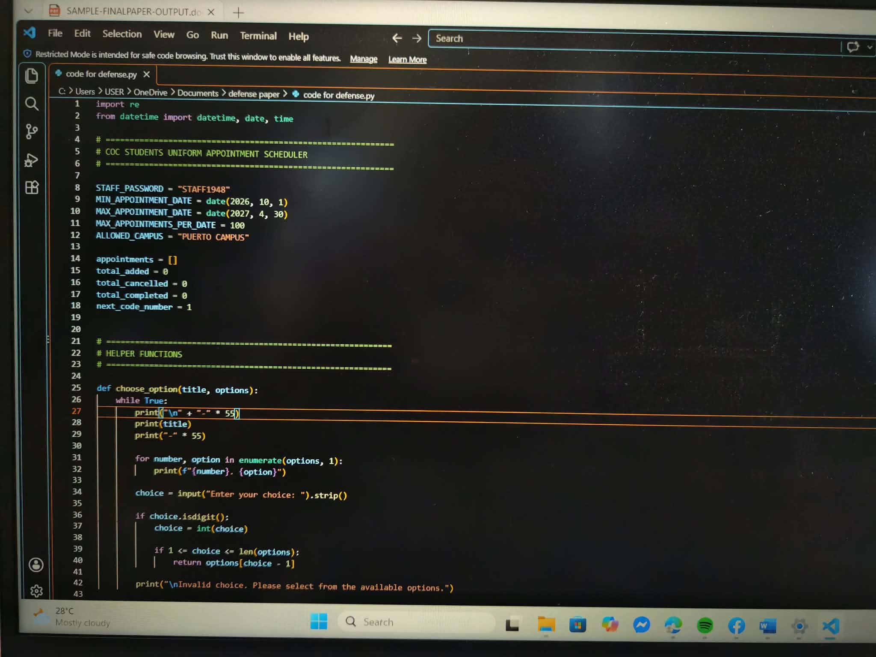

REFERENCE

Ampuan, A. D., & Delena, R. D. (2022). An implementation and evaluation of web-based
appointment system for the Mindanao State University–Main Campus. Journal of Information Systems and Informatics, 4(4), 922–937.
https://doi.org/10.51519/journalisi.v4i4.379

Cagayan De Oro College-PHINMA Education Network

Maala, R. F., Sebua, N. B., & Evangelista, K. L. L. (2023). Queuing management system
in Manuel S. Enverga University Foundation Candelaria Inc. International Journal of Advanced Research in Computer Science, 14(6), 44–53.
https://doi.org/10.26483/ijarcs.v14i6.7039

Wiratama, J., Sanjaya, S. A., Santoso, H., & Kurniadi, R. B. (2023). Development of
web-based school uniforms order application in a private school with prototyping model. International Journal of Science, Technology & Management, 4(6), 1612–1618.https://doi.org/10.46729/ijstm.v4i6.977

